Introduction to Fire Ecology Lesson Plan (1 of 6)

Author: Brittany Ciancarelli

Subject/Class: Science

Grade Level: 7th Grade

Standards: Aligned to Arizona State Science Standards (Grade 7)
http://www.azed.gov/standards-practices/science-standard/
-Grade 7, Strand 3, Concept 1, and Strand4, Concept 3: How can we interact better with our environment?

Goals: SWBAT demonstrate their understanding of a healthy vs. unhealthy Ponderosa Pine ecosystems, and the effects.

Learning Objectives:
1. SWBAT identify biotic and abiotic factors in a Ponderosa Pine ecosystem through a video and slideshow.
2. SWBAT identify and describe a Ponderosa Pine and its ecosystem through a reading.
3. SWBAT create a web of biotic and abiotic factors within a Ponderosa Pine ecosystem.
4. SWBAT discuss their opinion of a healthy vs. unhealthy Ponderosa Pine ecosystem, and explain why.

Materials/Resources:
-Pre/Post Fire Survey
-Student Handout 1: Abiotic and Biotic Factors in a Ponderosa Pine Ecosystem Article
-Fire Storm Video (June2011_LosConchas.mp4)
-Powerpoint of Ponderosa Pine Forest Pictures (Fire_Ecology_Slideshow_Workshop2013.ppt, slides 1-16)
*Survey, Video, and Powerpoint can be found on the website referenced in upper-right hand corner of this lesson.

-Student Handout 1 was adapted from these two website:
-http://cpluhna.nau.edu/Biota/ponderosa_forest.htm
-http://www.bentler.us/eastern-washington/plants/trees/pondersa.aspx

Set-Up

- Make enough copies for all students of the Pre/Post Fire Survey, Student Handout 1 and Student Handout 2.
- Set-up computer and projector to display powerpoint presentation and the fire storm video.
Procedures
Part 1: Introduction (25-30 minutes)
- Students will be asked to write down the goals and objectives.
- Distribute pre-survey for fire ecology to find out what students already know.
- Instructor gives geography introduction and pictures of the ponderosa pine forest. Students watch and record examples of biotic and abiotic factors that they see as part of the environment.
- Instructor plays the Fire Storm video. While viewing the video students continue to record any biotic/abiotic factors they see, as well as determine why we care about studying about fire.
- Instructor passes out the intro reading on Ponderosa Pine. Students read and take notes adding to their biotic/abiotic factors list, then create their own individual web.

Part 2: Group/Class Discussion and Activity (15-20 minutes)
- Students collaborate in groups sharing and discussing their individual webs and then creating one large web as a group. (See class web example below.) 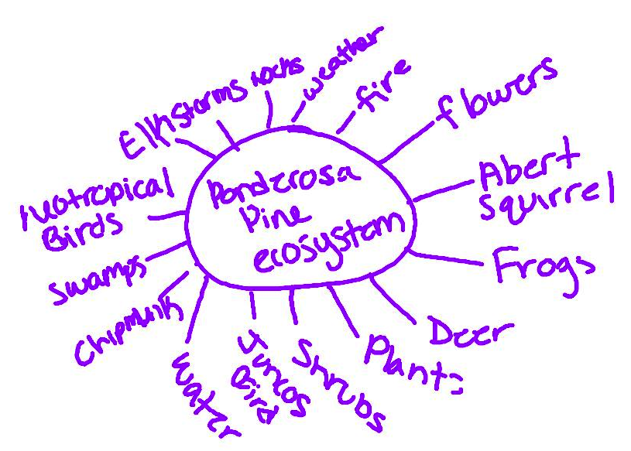
- Each group will then share out different parts of the Ponderosa Pine ecosystem from their webs to create one large class web.
- Instructor displays 2 pictures of a Ponderosa Pine forest, a less crowded and more crowded version. Students then discuss in pairs which is healthy and which is unhealthy and why.
Part 3: Closure/Review Activity and Homework (10 minutes)
- Instructor asks students to share their answers about which one is healthy and which one is not. Then instructor has students stand up and crowd together in a big close group. Ask, “what if I taught class like this every day, for the whole class with all of you standing together like this?” Ask them to share out why they would not like it. What are they competing for? (This can tie-in to the concept of competition in nature for a previous or upcoming unit). Discuss what is part of a healthy and what is part of an unhealthy ecosystem.

Student Handout 1: Biotic and Abiotic Factors of the Colorado Plateau Ponderosa Pine Forest

Forests of ponderosa pine cover many of the higher mesas and mountains of the Colorado Plateau from 6000 feet to about 8000 feet in elevation. On higher terrain above 6500 feet in the southern part of the region, including the Kaibab Plateau and atop the Mogollon Rim, ponderosa pine often forms nearly pure stands covering tens of thousands of acres. The forest stretching from near Flagstaff along the rim to the White Mountains region is the largest ponderosa pine forest on the continent.

The predominant form of the pine throughout the Colorado Plateau is the three-needled, Rocky Mountain ponderosa pine (Pinus ponderosa var. scopulorum). Gambel oak (Quercus gambelii) is a common associate of ponderosa pine at lower elevations in the forest along with New Mexico locust (Robina neomexicana). At higher elevations, associates include southwestern white pine (Pinus strobiformis), Rocky Mountain Douglas-fir, (Pseudotsuga menziesii var. glauca), Rocky Mountain white fir (Abies concolor var. concolor), and quaking aspen (Populus tremuloides). Common understory plants include grasses such as Arizona fescue and mountain muhly and forbs such as lupine. Buckbrush, cliffrose, currant, and apache plume can be seen growing beneath the tall, spreading crowns of the pines as well.

Ponderosa pine forests have a remarkably dynamic history on the Plateau. Evidence found in packrat middens, alluvial and cave sites, and in ancient pollen samples collected from lake, bog, and wetland sites throughout the region reveal almost no ponderosa pine during the middle (50,000-27,500 B.P.) and late (27,500-14,000 B.P.) Wisconsin time periods. Ponderosa pine areas today extend into the moister, cooler mid-elevation forest and mix with interior Douglas fir, western larch, quaking aspen, and lodgepole pine.

This is a hardy, drought tolerant tree with thick, protective bark comprised of stacked plates that sometimes look like puzzle pieces. The deep cracks in old tree bark smell pleasant, like vanilla with a hint of butterscotch or warm cookie. Ponderosa needles are bundled in threes and they are five to ten inches long, forming tufts at branch ends, with three to six inch long pine cones having sharp teeth. Old growth ponderosas grow 150 to 180 feet tall and 3 to 4 feet in diameter. Some people refer to ponderosa pine trees in logging terms as bull pine or yellow pine depending on the quality of its wood.
Fire is a critical factor in the ecology of ponderosa pine, so relatively subtle changes in climate such as the timing of seasonal rains and their associated lightning strikes, may have a larger impact on ponderosa pine than on some other western conifers.

Today, the typical climate of a ponderosa pine forest includes an adequate, annual amount of moisture for good vegetative growth and conditions favorable for frequent early summer fires. Winters are relatively mild (average slightly above 30° F) and precipitation as snow saturates the soil. The spring dry season is accompanied by increasing air temperatures, low humidity, and persistent winds. The drought is broken in early to mid-July with the development of almost daily thunder and lightning storms, especially along the southern edge of the Colorado Plateau in areas such as the Mogollon Rim and White Mountains. July and August are the wettest, warmest months. A second dry season occurs in the fall. This climatic pattern is particularly conducive for development of a pine-grass savanna maintained by frequent surface fires.

Before European settlement, widespread surface fires that occurred every 2-15 years favored grasses and limited pine densities. Early explorers described majestic, open stands with rich grasses and occasional shrubs beneath, as young ponderosa seedlings were often killed by the low-intensity fires while mature pines, with their thick yellowish red bark, were only scarred. The effects of grazing and fire suppression since the late 1880s on ponderosa pine forests have been profound, including a shift to forests with very high tree densities, which in turn has contributed to destructive forest fires.

The tassel-eared Abert's squirrel is a distinctive inhabitant of ponderosa pine forests on the central and southern Colorado Plateau. Few mammal species are so closely tied to a particular tree as this squirrel is to ponderosa pine. The bushy-tailed squirrel uses the tree for nesting, shelter, and food, feeding on the ponderosa's seeds and the tree's cambium layer. Abert's squirrels can be quite acrobatic, sometimes jumping 40 feet or more to the ground unharmed.

Mule deer and rocky mountain elk also live among the pines along with smaller mammals including numerous chipmunks and voles.

Ponderosas provide food and shelter for a wide variety of birds at the edge of the shrub-steppe including northern flicker, Lewis's woodpecker and other woodpeckers, Steller's jay, brown creeper, white and red-breasted nuthatches, juncos, red-shafted flicker, and the colorful western tanager, a summer resident from the tropics. Ponderosa pine are also the favorite nesting tree for the colorful neotropical bird, western tanager, which migrate north from Cenral America to breed. Ponderosas make good roosts for turkey vulture, wild turkey and raven, sallying perches for Western bluebird, and nest and hunting platforms for red-tailed hawk, osprey, bald eagle, American kestral, merlin, great horned owl, and various other raptors. Loose, deep-furrowed bark and abandoned nest cavities of dying ponderosas also provide shelter for mouse-eared bats that flip-flap in desert nights hunting mosquitos and moths, and for pallid bats that forage for ground-dwelling insects including beetles. Ponderosas also feed and shelter a variety of insects of course, from pine seed bugs to flathead borer beetles to ants, to butterflies such as pine white and western pine elfin, in turn providing a major food source for various birds and mammals.

Young ponderosas provide winter browse for mule deer to survive tough winters while older stands may get infested with dwarf mistletoe, a plant parasite that is the host plant for the thicket hairstreak and other mistletoe butterflies. Rocky mountain elk also live among the pines along with smaller mammals including numerous chipmunks and voles.

Ponderosas seedlings planted at the edge of open country should be planted from local stock or seeded from local trees to ensure good adaptation and should be shaded from blazing summer sun, caged from deer, and if possible, watered in summer until roots reach deep moisture in a year or two.

